

**Semester One Examination 2017**

**Question/Answer Booklet**

**MATHEMATICS SPECIALIST**

**UNIT 3**

**Section Two:**

**Calculator-assumed**

Student Name: _____________________________________

Teacher’s Name: _____________________________________

**Time allowed for this section**

Reading time before commencing work: ten minutes

Working time for paper: one hundred minutes

**Material required/recommended for this section**

**To be provided by the supervisor**

This Question/Answer booklet

Formula Sheet (retained from Section One)

**To be provided by the candidate**

Standard items: pens(blue/black preferred), pencils(including coloured), sharpener, correction tape/fluid, erasers, ruler, highlighters

Special Items: drawing instruments, templates, notes on two unfolded sheets of A4 paper, and up to three calculators approved for use in the WACE examinations.

**Important note to candidates**

No other items may be taken into the examination room. It is **your** responsibility to ensure that you do not have any unauthorised notes or other items of a non-personal nature in the examination room. If you have any unauthorised material with you, hand it to the supervisor **before** reading any further.

**Structure of this paper**

|  |  |  |  |  |  |
| --- | --- | --- | --- | --- | --- |
|  | Number of questions available | Number of questions to be attempted | Suggested working time (minutes) | Marks available | Weighting |
| Section One  Calculator—free | 7 | 7 | 50 minutes | 50 | 35% |
| **Section Two**  **Calculator—assumed** | **11** | **11** | **100 minutes** | **100** | **65%** |
|  | | | | 150 | 100% |

**Instructions to candidates**

1. The rules for the conduct of Western Australian external examinations are detailed in the *Year 12 Information Handbook 2017.* Sitting this examination implies that you agree to abide by these rules.
2. Answer the questions according to the following instructions.

Section Two: Write answers in this Question/Answer Booklet. Answer **all** questions.

**Show all your working clearly.** Your working should be in sufficient detail to allow your

answers to be checked readily and for marks to be awarded for reasoning. Incorrect

answers given without supporting reasoning cannot be allocated any marks. For any

question or part question worth more than two marks, valid working or justification is required to receive full marks. If you repeat an answer to any question, ensure that you cancel the answer you do not wish to have marked.

It is recommended that you **do not use pencil**, except in diagrams.

1. You must be careful to confine your responses to the specific questions asked and to follow any instructions that are specific to a particular question.
2. Spare pages are included at the end of this booklet. They can be used for planning your responses and/or as additional space if required to continue an answer.

* Planning: If you use the spare pages for planning, indicate this clearly at the top of the page.
* Continuing an answer: If you need to use the space to continue an answer, indicate in the original answer space where the answer is continued, i.e. give the page number. Fill in the number of the question that you are continuing to answer at the top of the page.

1. The Formula Sheet is **not** handed in with your Question/Answer Booklet.

# Section Two: Calculator–assumed 100 marks

This section has **eleven (11)** questions. Attempt **all** questions. Write your answers in the spaces

provided.

Working time: 100 minutes

**Question 8 (6 marks)**

The graph below shows the function $f\left(x\right)=\frac{ax^{2}+bx+c}{mx+n}= \frac{k}{x-2}+(-\frac{x}{2}+1)$

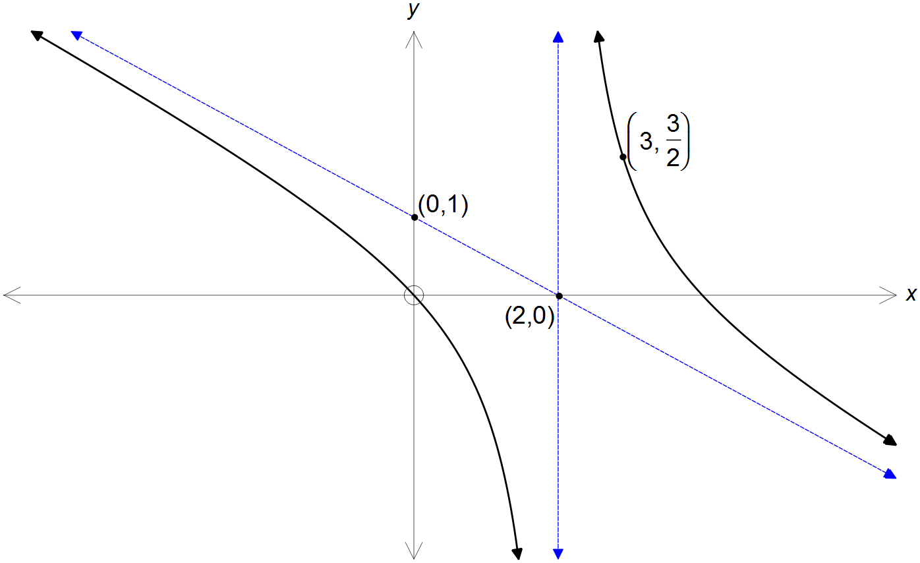

(a) State the equations of the asymptotes shown. (2 marks)

(b) Hence, or otherwise, determine the value of the constants $a, b, c, m$ and $n$. (4 marks)

**Question 9 (11 marks)**

A particle moves so that at any time $t≥0$ its acceleration is given by:

ms-2

The particle begins its motion at the origin with a velocity ms-1.

(a) Determine the velocity $v(t)$ and position $r(t)$ of the particle for any time $t$. (4 marks)

**Question 9 (Continued)**

(b) Does the particle ever come to a stop? If yes, determine where and when it comes to a stop.

If not, then explain why not.

(3 marks)

(c) Determine the exact position and speed of the particle when it is moving parallel

to the *x* axis. (4 marks)

**Question 10 (10 marks)**

The graph of $f\left(x\right)=4-{\left(x+1\right)}^{2}$ is shown below.

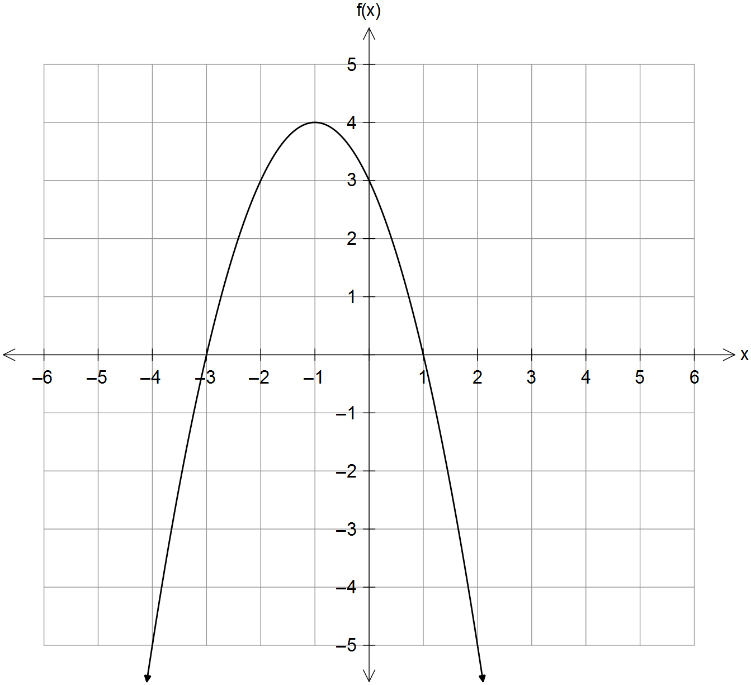

(a) Sketch the graph of $\frac{1}{f(x)}$ on the grid below. (4 marks)

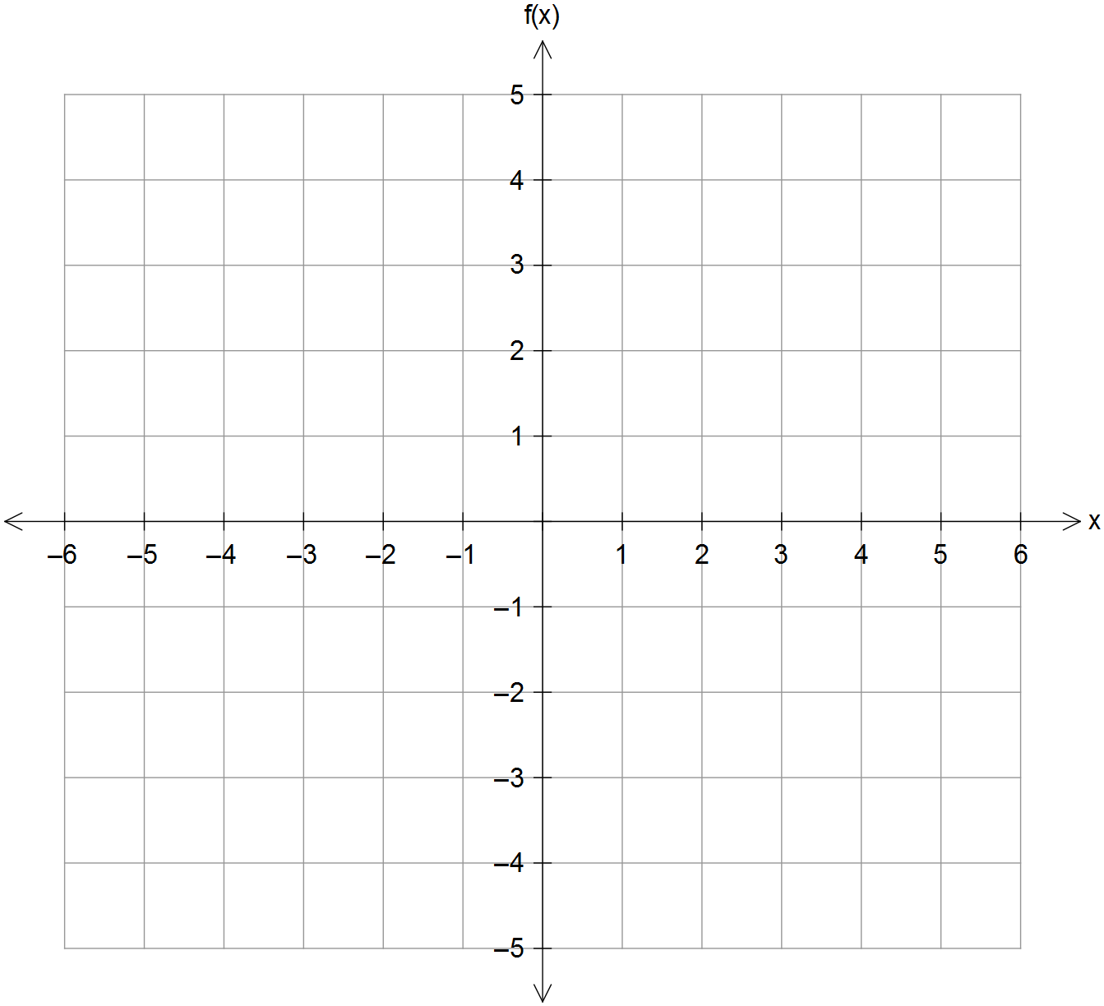

**Question 10 – Continued**

(b) Sketch the graph of $\left|f\left(\left|x\right|\right)\right|$ on the grid below. (3 marks)



(c) The domain of $f(x)$ is restricted to $x≥k$ so that $y=f^{-1}(x)$ exists.

Determine the value of $k$ and state the domain and range of $f^{-1}(x)$. (3 marks)

**Question 11 (8 marks)**

A sphere is given by the equation $x^{2}+y^{2}+z^{2}-2x+2y-7=0$.

(a) The intersection of the sphere and the xz plane follows the outline of a circle.

Determine the centre and radius of this circle. (4 marks)

(b) The plane $r∙n=k$ is tangent to the sphere at the point $\vec{OP}=3i+j+k$.

Determine the Cartesian equation of the plane. (4 marks)

**Question 12 (8 marks)**

(a) The function $F\left(x\right)=\cos^{2}\left(1-x\right)$ is defined as $F\left(x\right)=f∘g∘h(x)$.

State a possible set of functions $f\left(x\right), g(x)$ and $h(x)$. (3 marks)

(b) Two functions $f(x)$ and $g(x)$ are defined and graphed below for $-4<x<4$.

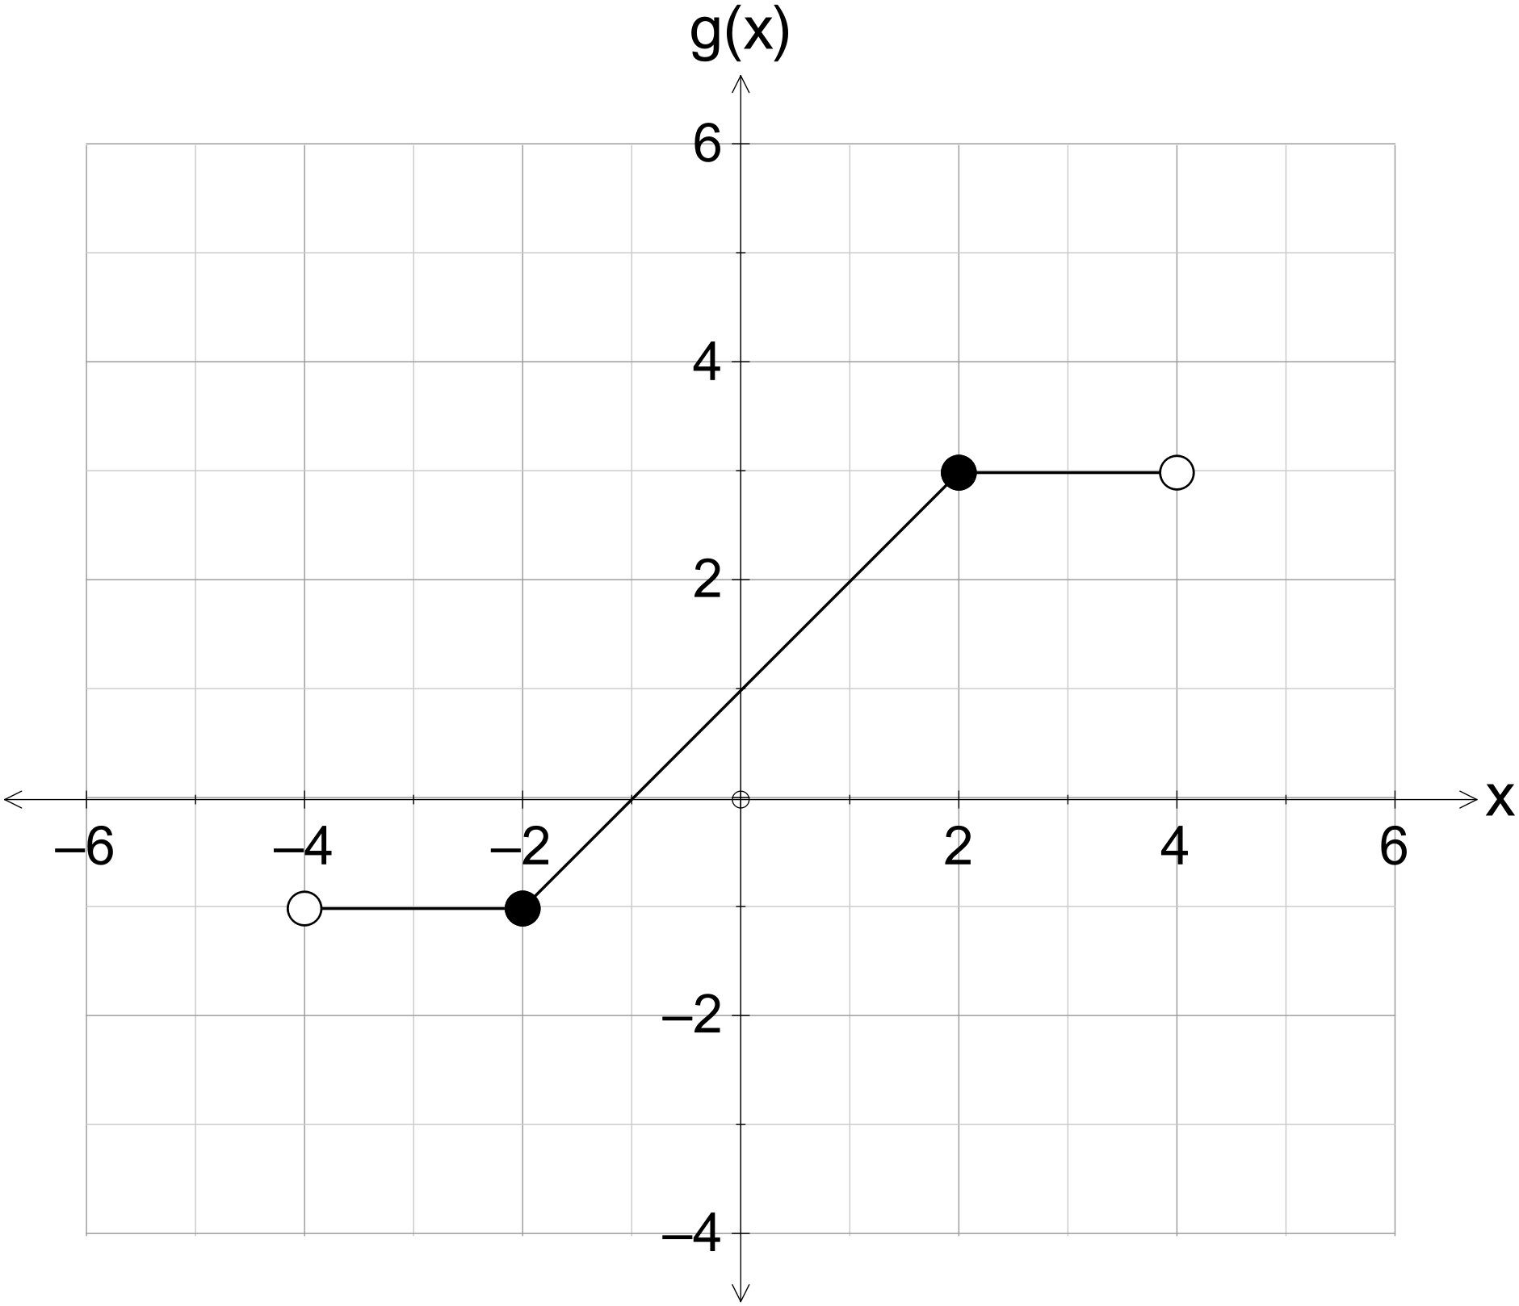

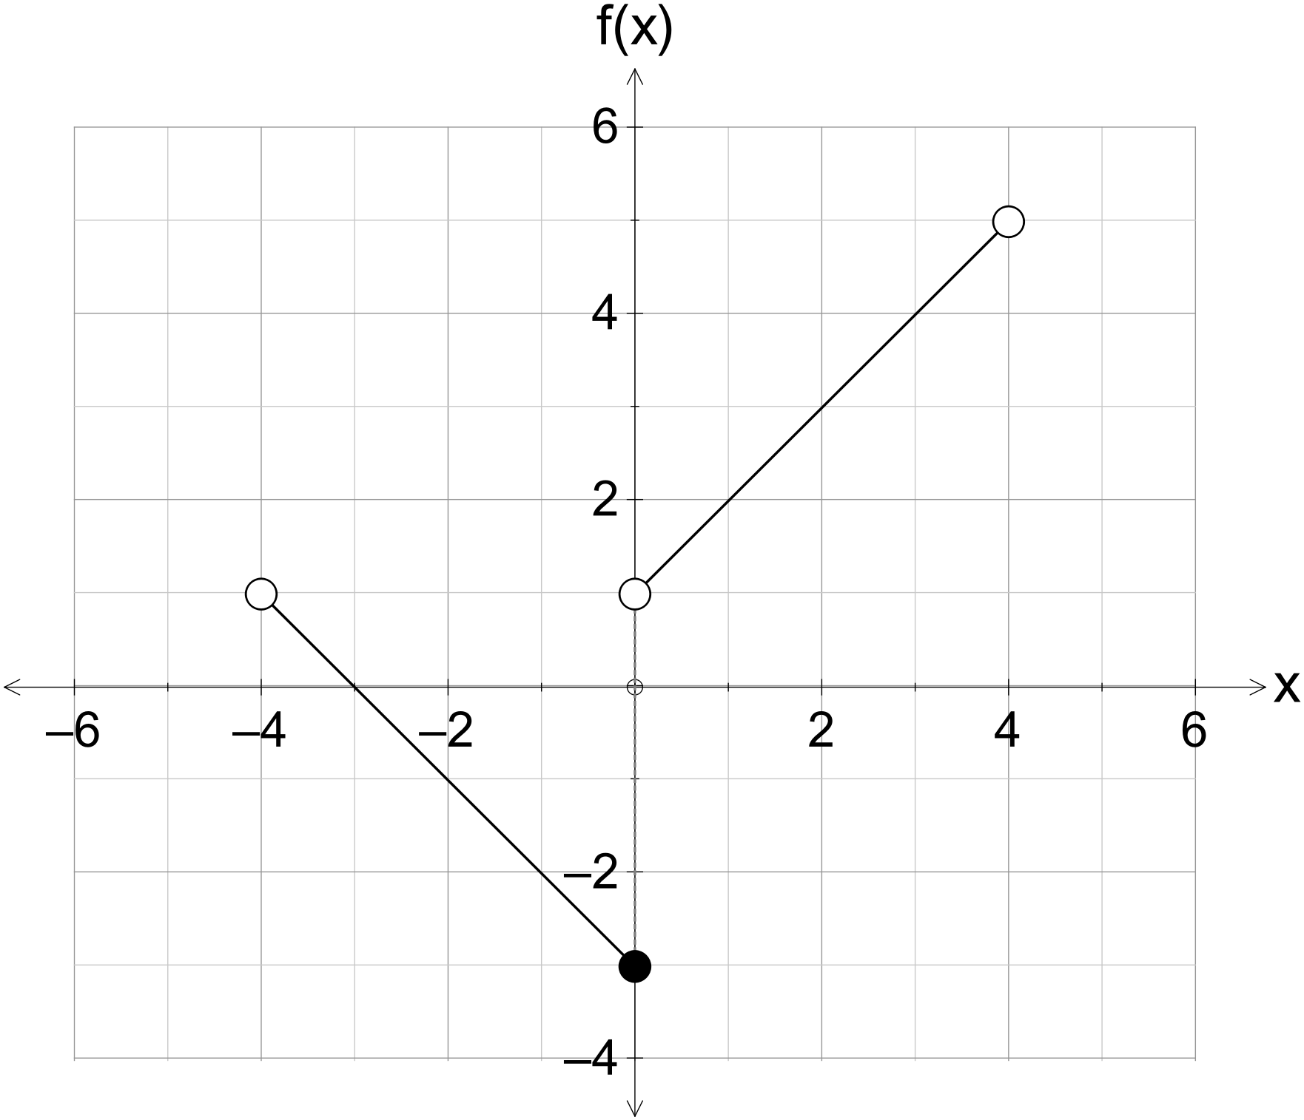

(i) Determine $f∘g(1)$ and $f∘f(-3)$ (2 marks)

(ii) Sketch $gf(x)$ on the axes below assuming the required restrictions on $f(x)$. (3 marks)

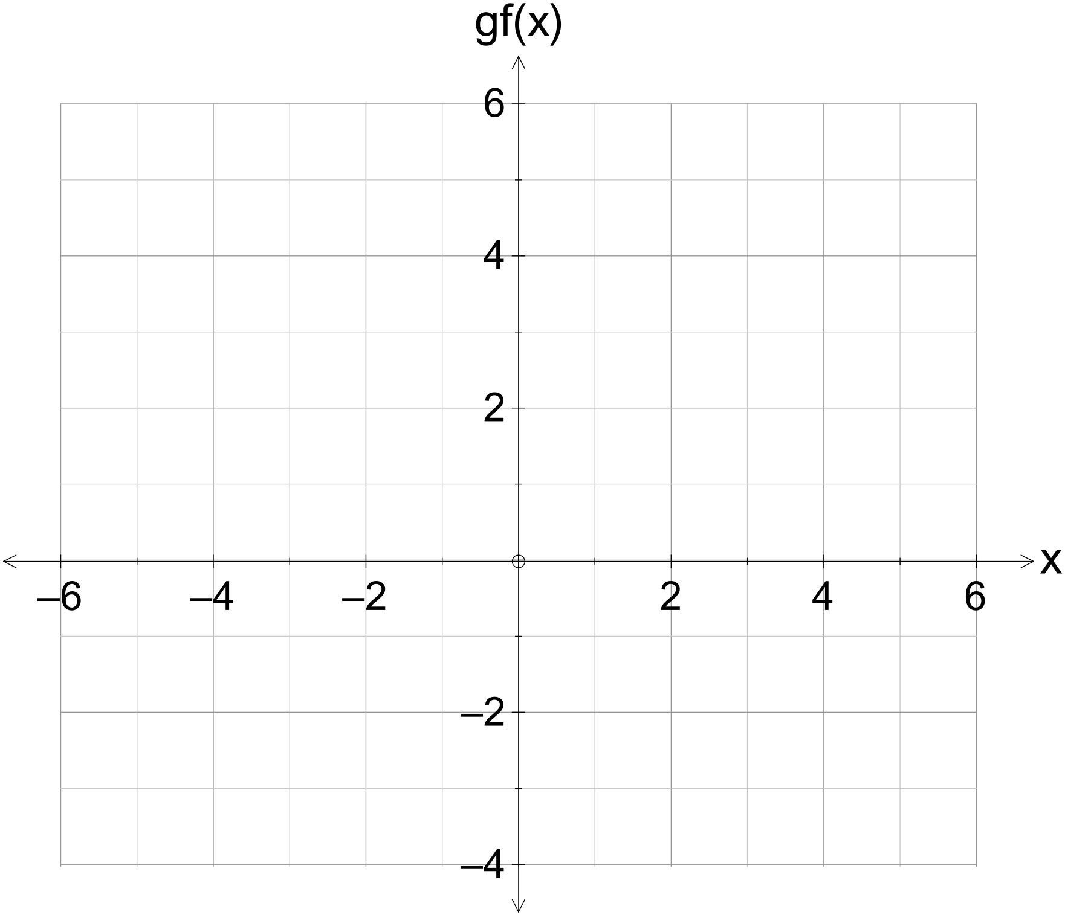

**Question 13 (10 marks)**

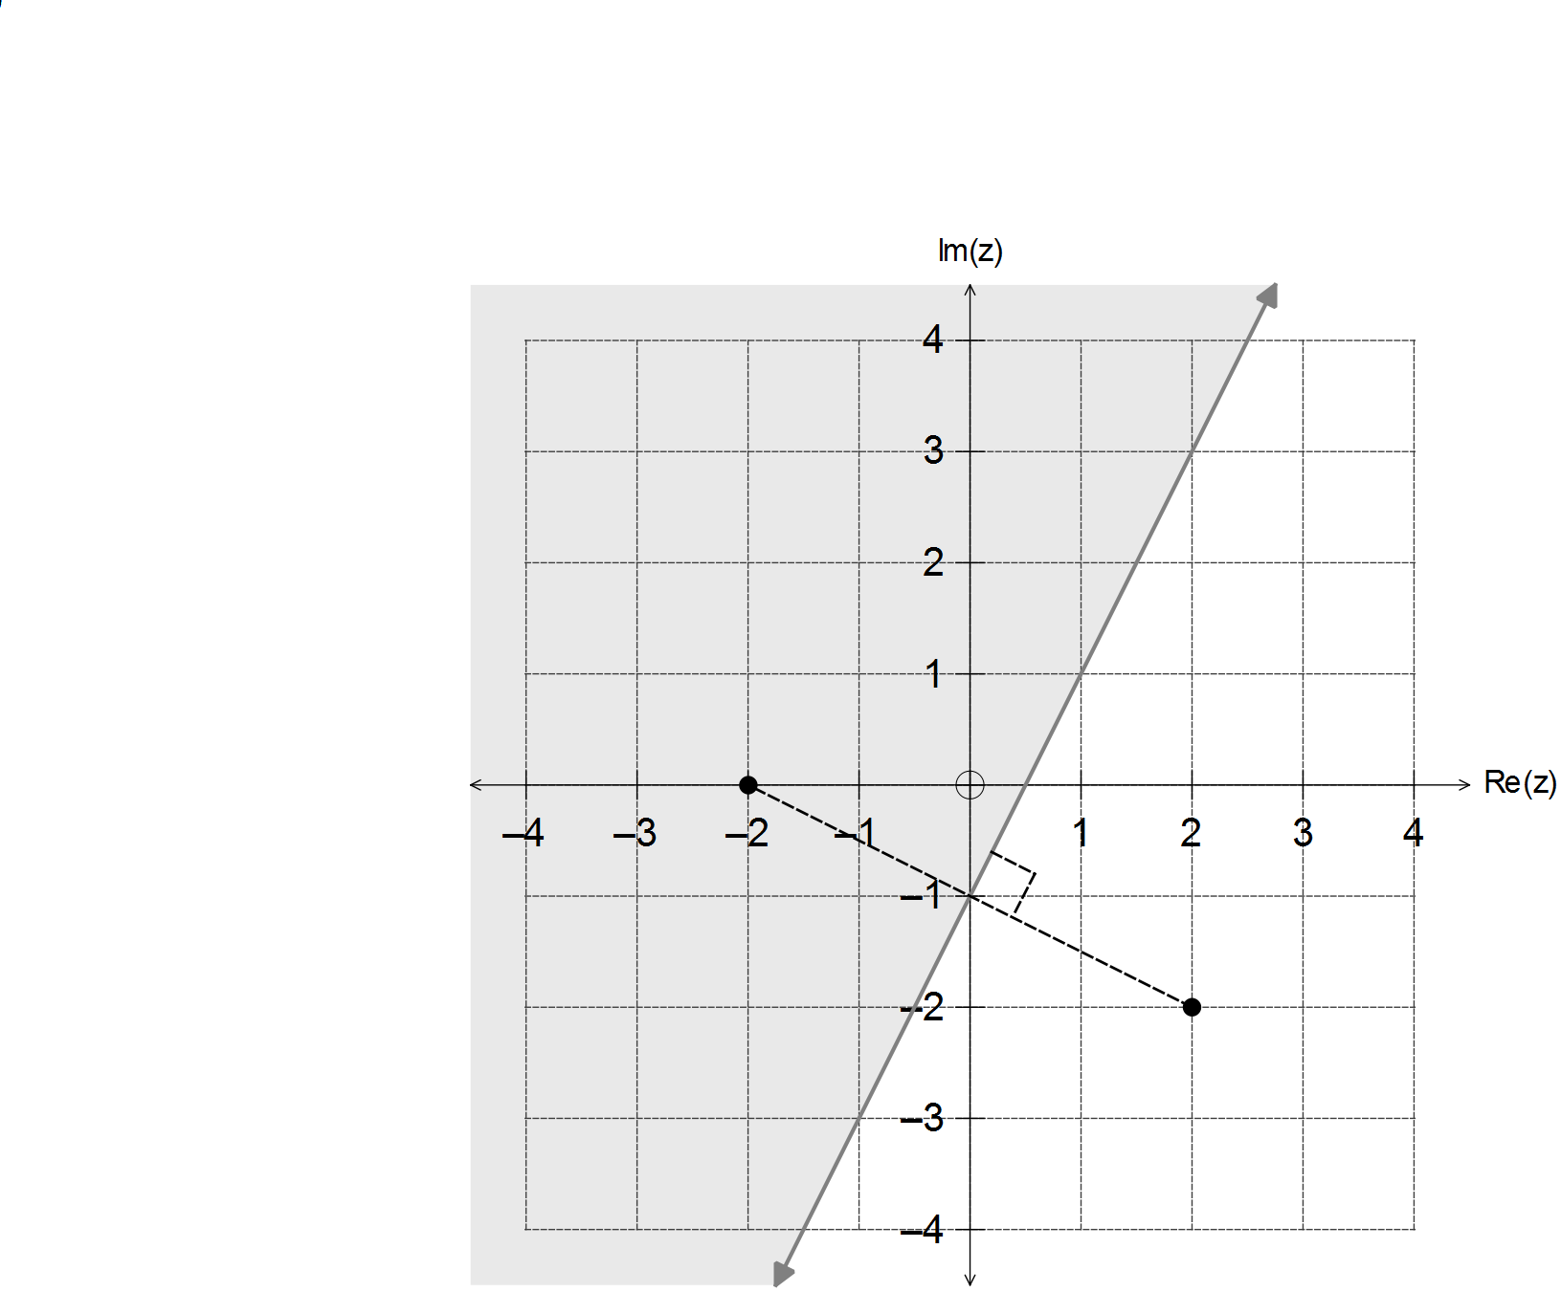

(a) State the conditions that define the complex locus shown below. (3 marks)

(b) Sketch the following sets of points in the Argand planes provided.

(i) $\left\{z: \left|z\right|≤arg\left(z\right) for 0≤\arg\left(z\right)≤2π\right\}$ (2 marks)

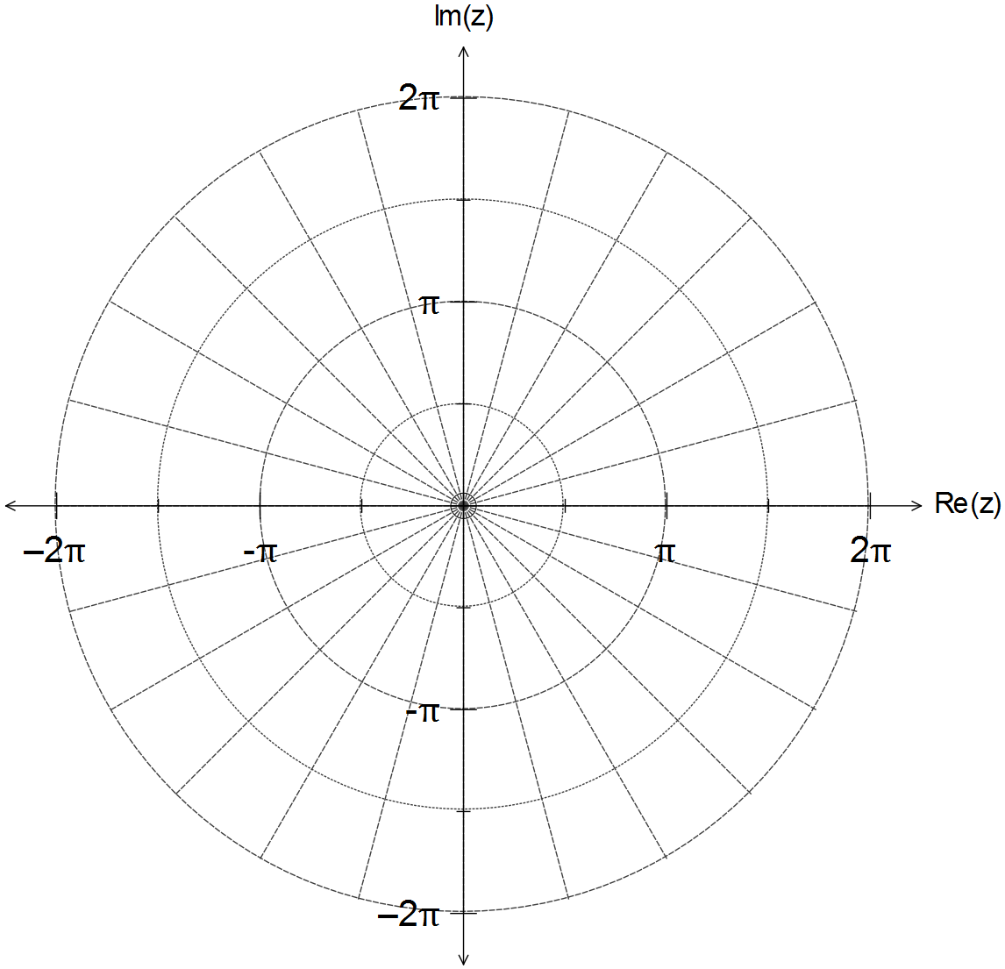

**Question 13 (Continued)**

(ii) $\left\{z:arg\left(\frac{z + 1}{z + i}\right)=\frac{π}{4} \right\}$ (5 marks)

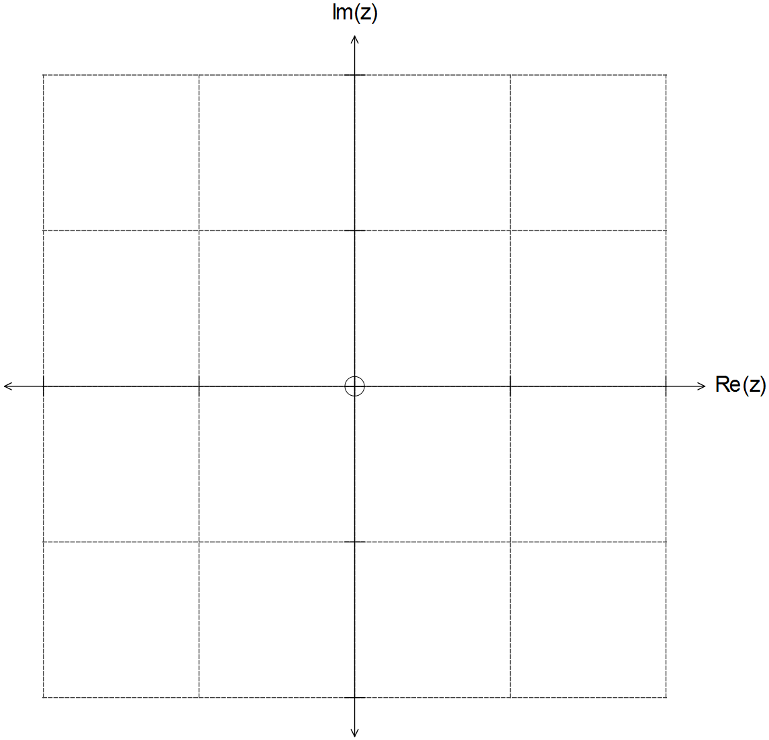

**Question 14 (11 marks)**

A fireworks display consists of 30cm diameter shells that can travel at an average speed of 100 ms-1 and detonate at a designated height that ranges from 300m to 400m off level ground.

Shell A is fired from $\left(80i-120j\right)$ metres relative to the control centre at O, with velocity ms-1.

(a) If Shell A is programmed to detonate four seconds after launch, determine the height

at which it detonates. (1 mark)

(b) A spectator at $\left(-200i+350j+20k\right)$ metres from O watches the detonation of Shell A from

her balcony. If sound travels at ms-1, determine the time lapse between seeing and

hearing the detonation. (4 marks)

**Question 14 – Continued**

(c) Use the scalar product to determine the angle of inclination from level ground that Shell A

was fired at, and state the speed at which it occurs. (4 marks)

(d) If Shell B is fired simultaneously as Shell A from $\left(120i-40j\right)$, determine the velocity of

Shell B so that both shells detonate simultaneously at the same location. (2 marks)

**Question 15 (14 marks)**

(a) In the Argand plane given below the complex numbers $z$ and $w$ are drawn as vectors.

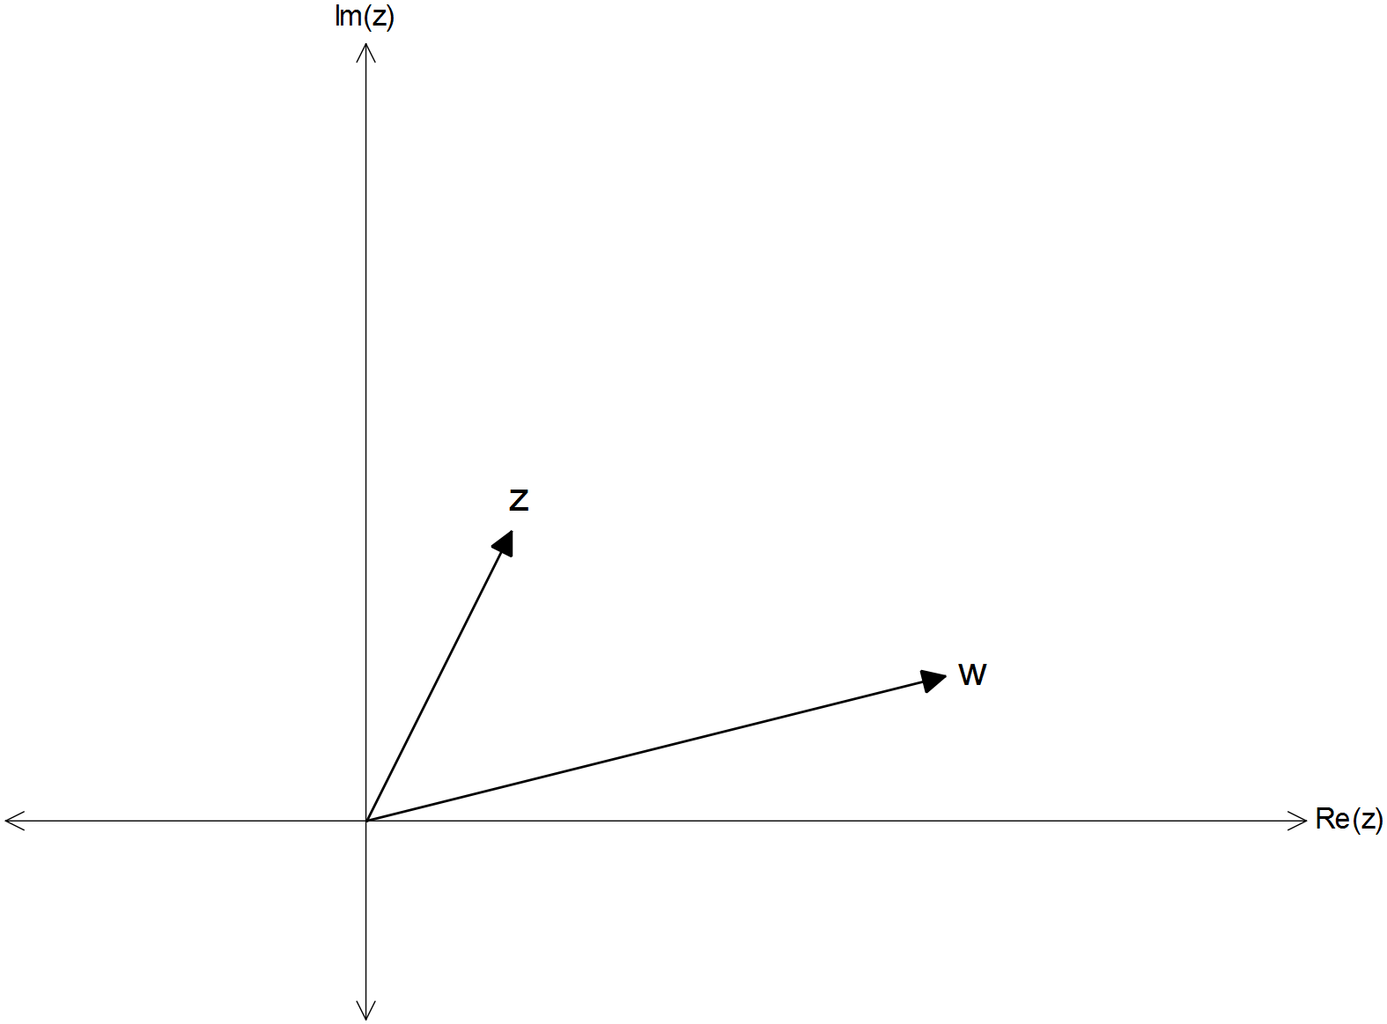

(i) Draw $\left(z+w\right)$ and $\left(z-w\right)$ as vectors on the same diagram above. (2 marks)

(ii) If $\left|z+w\right|=\left|z-w\right|$, show that $\left|\arg\left(z\right)-\arg\left(w\right)\right|=\frac{π}{2}$. (4 marks)

**Question 15 (Continued)**

(b) In the complex plane, the unit circle has its centre at $\left(0, 0\right)$ and has a radius equal to one unit.

If the complex number $u$ represents a point on the unit circle, find the value of:

$${\left|i+u\right|}^{2}+{\left|i-u\right|}^{2}$$

(4 marks)

(c) The complex number $z=x+yi$ has magnitude $r>0$ and argument $θ$, with $0<θ<\frac{π}{2}$.

Determine the magnitude and argument of each of the following, in terms of $r$ and $θ$.

(i) $iz^{2}$ (2 marks)

(ii) $-2y-2xi$ (2 marks)

**Question 16 (7 marks)**

Consider the polynomial $P\left(z\right)=z^{5}+z^{4}-z^{3}+z^{2}+z-1$.

(a) Determine the polynomial $Q(z)$ for which $Q\left(z\right)\left(z^{3}+1\right)=P(z)$. (2 marks)

(b) Hence, or otherwise, determine all the values of $z$ for which $P\left(z\right)=0$. (5 marks)

**Question 17 (8 marks)**

Consider the complex number $z=\operatorname{cis}{θ}$ and the expansion of $z^{n}={\left(\cos{θ}+i\sin{θ}\right)}^{n}$.

(a) Use De Moivre’s theorem to express $\cos\left(4θ\right)$ in terms of $\cos{θ}$. (5 marks)

(b) Use your result in (a) to solve the equation $8x^{4}-8x^{2}+1=0$. (3 marks)

**Question 18 (7 marks)**

Consider the non-zero vectors $a, b$ and $c$.

(a) If $a∙\left(b×c\right)=0$, what can be said about $a, b$ and/or $c$? Explain. (4 marks)

(b) Prove that $\left(a+b\right)×\left(a-b\right)=2\left(b×a\right)$ (3 marks)

**Additional working space**

**END OF QUESTIONS**

Question number(s): ……………………

**Additional working space**

Question number(s): ……………………

**Additional working space**

Question number(s): ……………………

**Additional working space**

Question number(s): ……………………

WATP acknowledges the permission of School Curriculum and Assessment Authority in

providing instructions to students.